SNOWFLAKE PERFORMANCE MANAGEMENT
CACHING
Caching is another way of improving performance in snowflake

Let’s understand what caching is???
"Caching" refers to layers of stored data that help improve query performance by reducing the need to access data repeatedly from disk storage. Snowflake implements caching at several levels
At high level architecture we have 3 layers and each layer has different type caching as shown
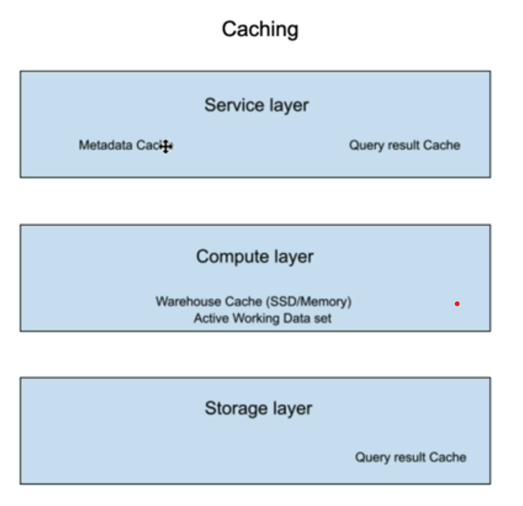

In below image if any terms are not understood, we will see later
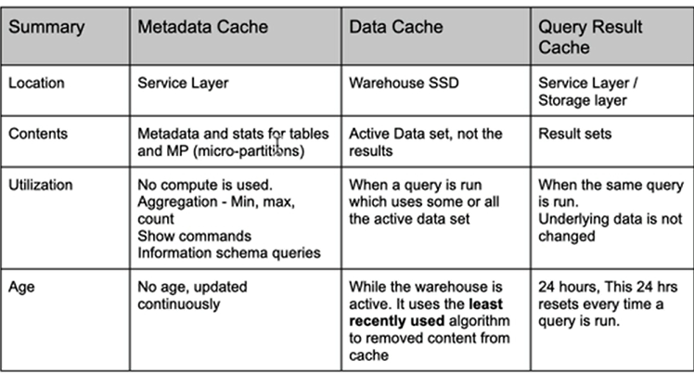

Let’s understand in practical
Check that the warehouse in suspended state. The warehouse cache is cleared if it is in suspended state.

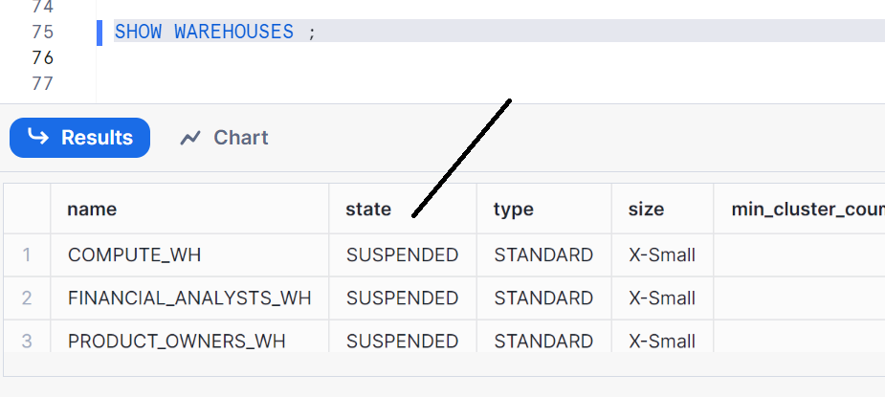
Running First Time in warehouse - Warehouse cache will not be used and result cache will not be used
Alter session set use_cached_result = false;
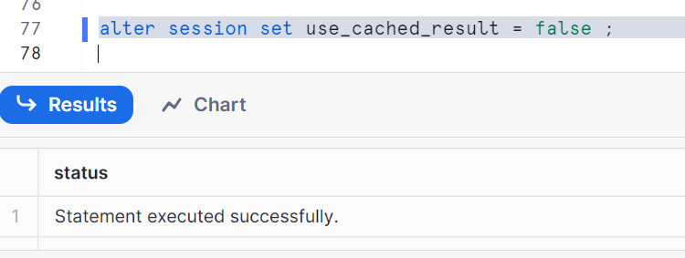
Let’s run a little complicated query which comes back in few seconds
Select ca_state, ca_city, count(*)
from customer_address
join customer on c_current_addr_sk = ca_address_sk
where ca_state in ('NC','OH','NY','TX','MT','VA','OK','GA','MN','KY')
group by ca_state, ca_city;
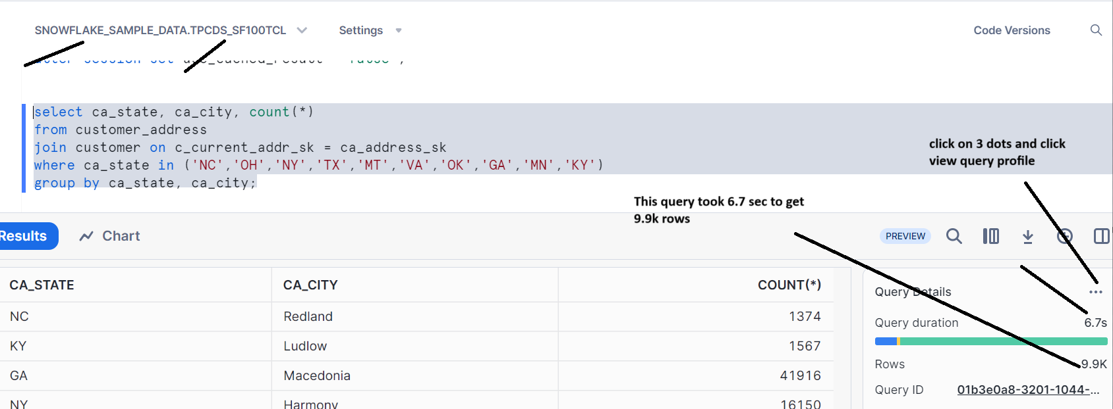
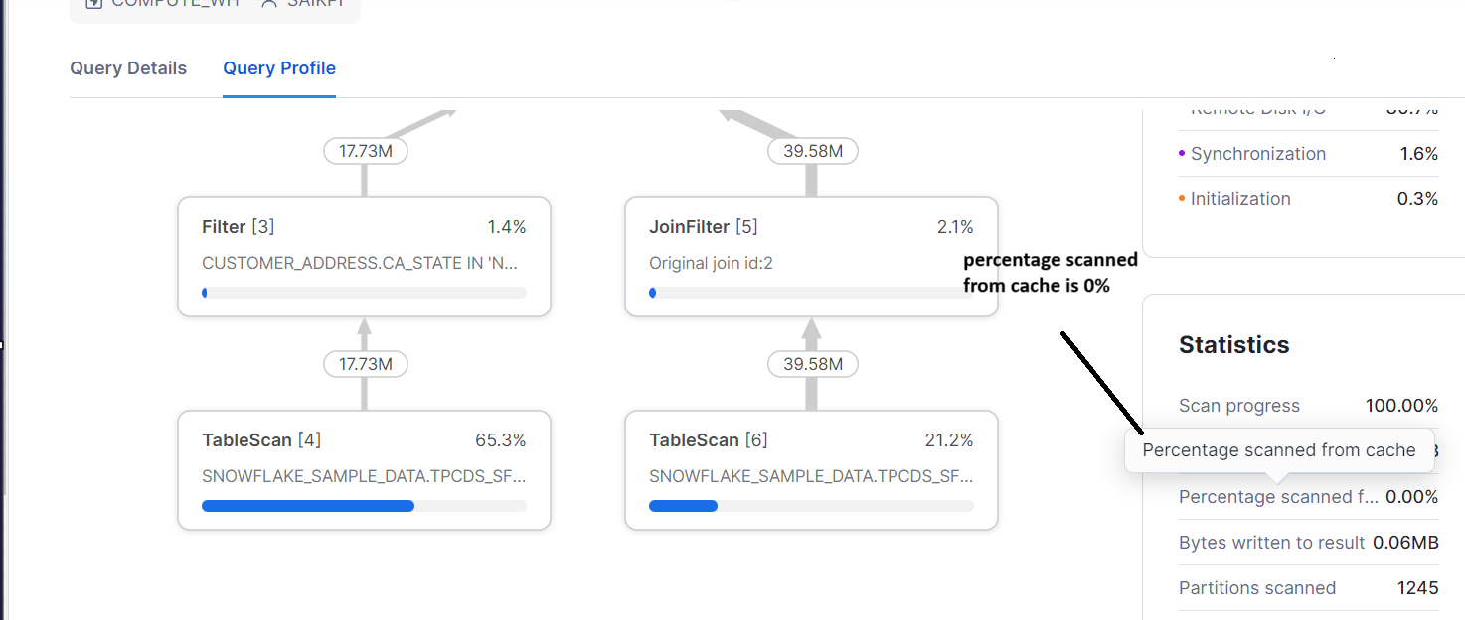
Now run the same query again
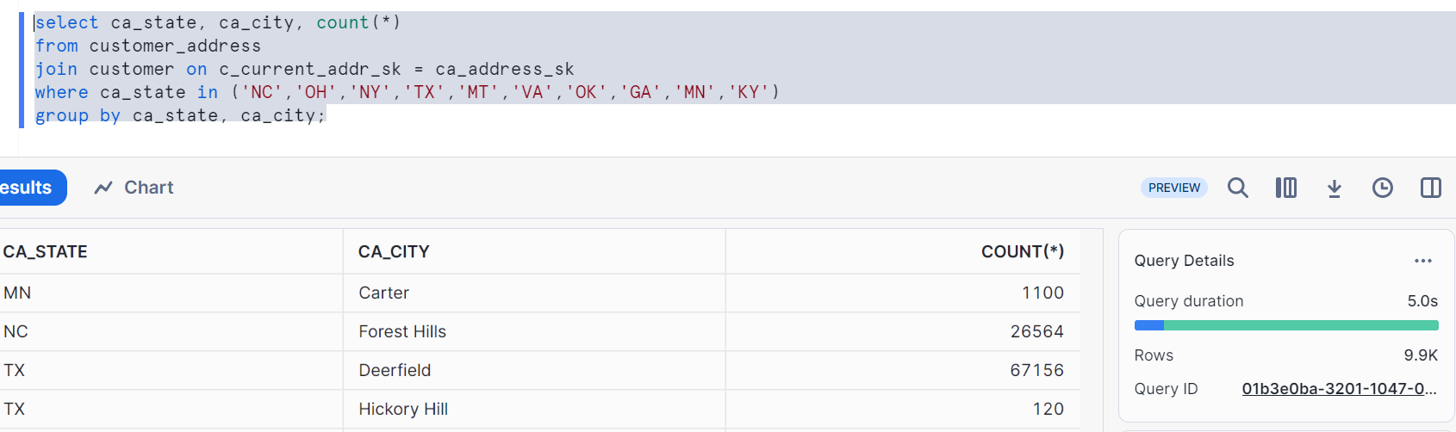
It ran in 5 sec which is better than previous. Let’s go to view query profile on 3 dots
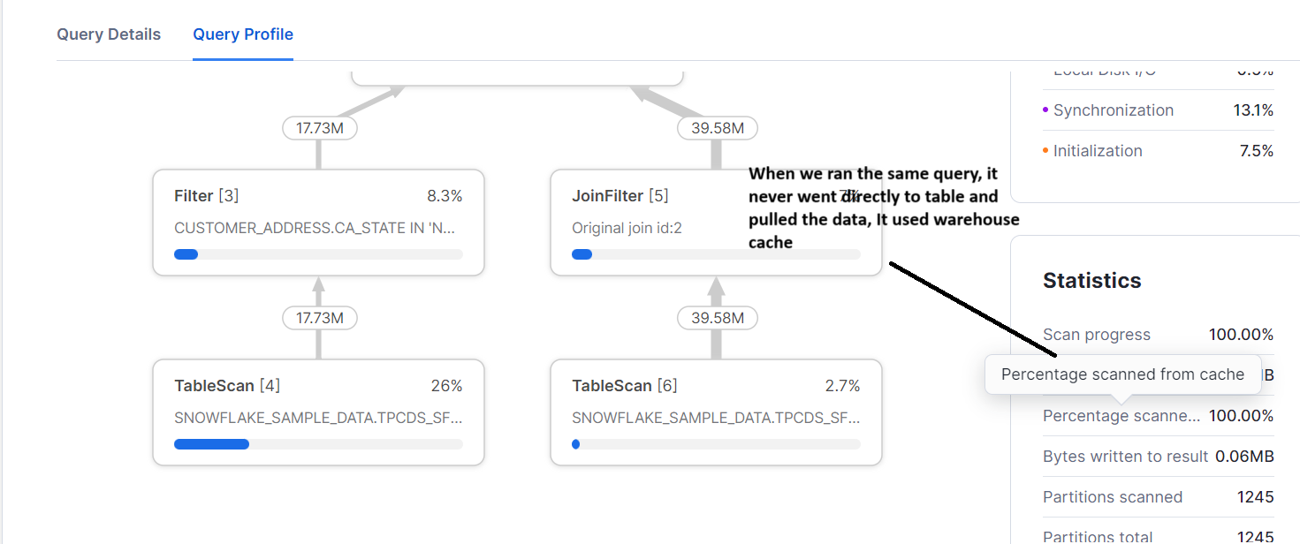Now let’s enable the result cache
Alter session set use_cached_result = true;
Run the same query
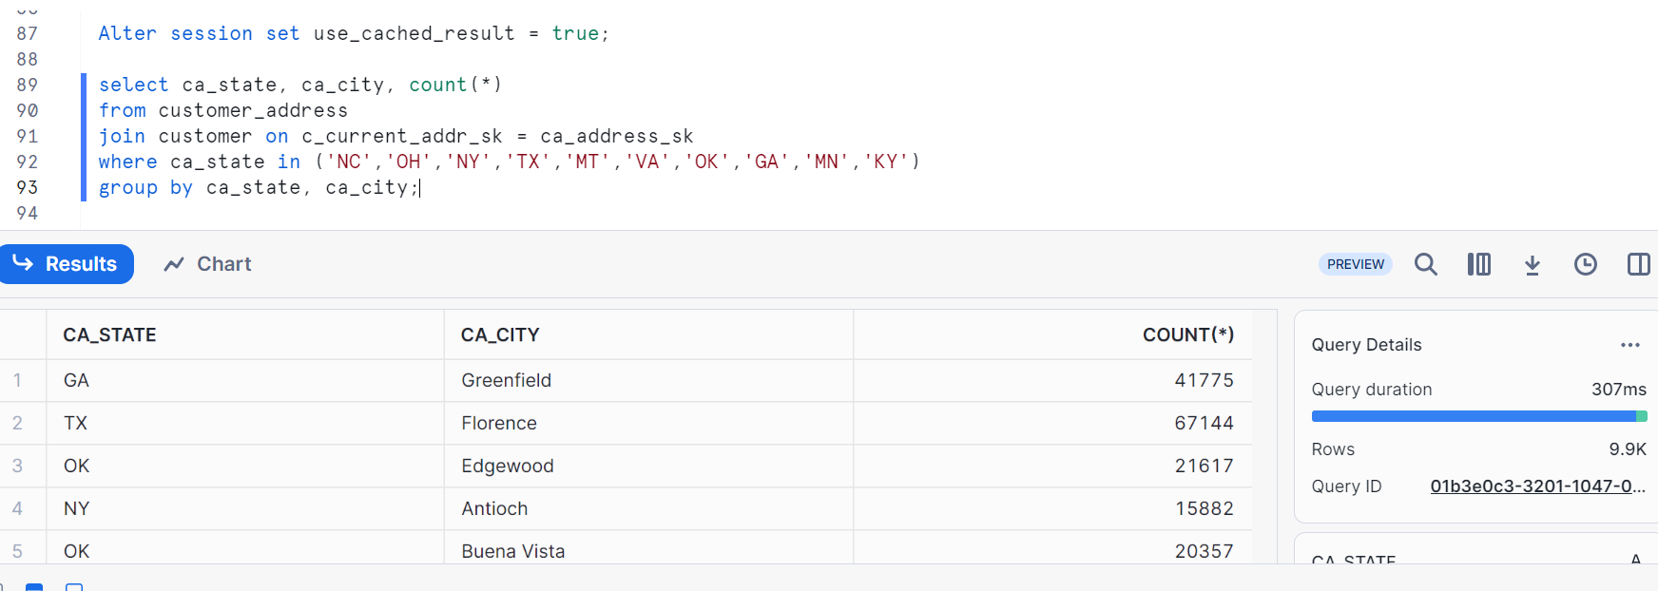
Now we got our results in 307 sec. CHECK QUERY PROFILE
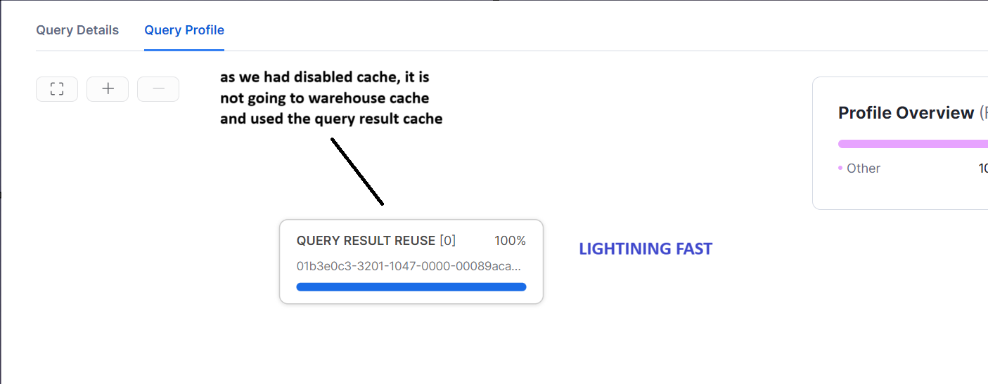
Now let’s see if a different user sends the same query to the warehouse. It should use result cache
Note result cache is true by default, we have set it false to show the usage of warehouse cache
As per previous posts snowflake_8, create role PRODUCT_OWNERS_ROLE and grant usage to compute_WH and create a user ADAM (we had seen earlier)

Now let’s sign out and login to user ADAM and run the same query
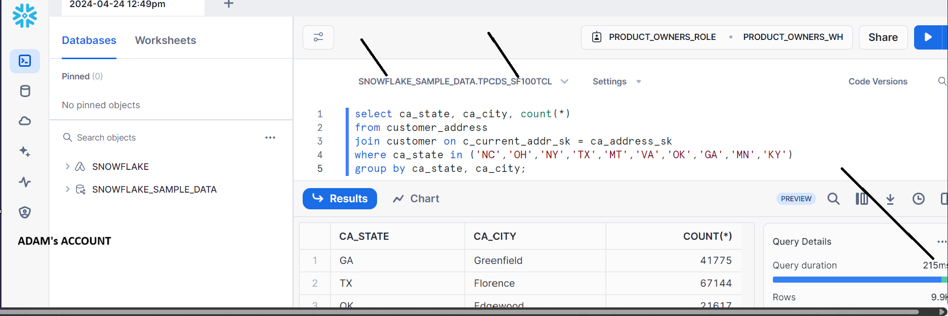
uses query result cache
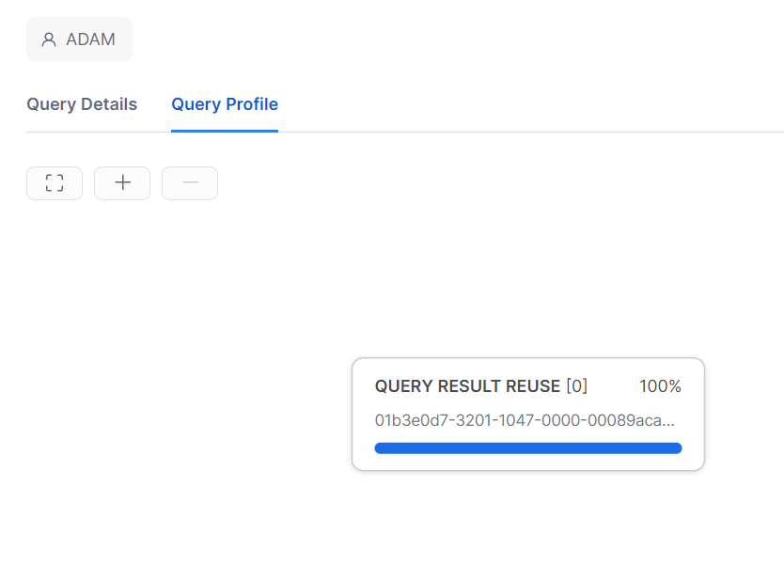
Query Result cache stores results for 24 hours and if underlined data is changed it refreshes the cache

To conclude, it is recommended to create a dedicated warehouse, identify and classify your loads, if you have users & executing same queries, it improves performance by creating dedicated warehouse
Meta data cache: It is used to store Meta data about the tables and stores some of the aggregate function values so that it doesn’t need to go to warehouse for compute power to give you results

